졸업논문제출서

성명:
학과:
학번:

위 본인은 한양대학교 자연과학대학 화학과 2026년 2월 학사 졸업을 위하여 다음과 같이 졸업 논문을 제출합니다.

논문제목:

제출자: (본인사인)

지도교수: (지도교수사인)

제출일자: 2025년 월 일

[초록양식]
(처음띄우기없음)(용지위:3cm 아래:2.54cm 왼쪽:2.54cm 오른쪽:2.54cm-워드여백기본)
Improved Accuracy for the Determination of Density of
Polyethylene Pellets using Transmission Raman Spectroscopy(fonts: Times New Romans, 16points, Bold, 가운데맞춤)
(1줄띄기)
Mooeung Kim and Hoeil Chung(10poinsts, Bold, 가운데맞춤, full name)
Analytical Spectroscopy Lab, Department of Chemistry, Hanyang University, Seoul
E-mail: hoeil@hanyang.ac.kr (10points, 가운데맞춤)
(1줄띄기)
[Introduction] (10points, Bold, 왼쪽맞춤)
(10points, 좌우맞춤, 첫칸띄기)Recently, transmission Raman spectroscopy has been proposed as an alternative to conventional back-scattering mode for Raman spectral collection. Transmission Raman measurement is based on the collection of Raman signal at the opposition side of the laser illumination, so Raman spectra representing bulk content of samples can be acquired. To demonstrate analytical potential of transmission Raman for bulk analysis of solid sample, we have attempted to determine the density of measuring the density of polyethylene (PE) pellets. WAI scheme was based on back-scattering Raman collection and capable of simultaneously illuminating laser beam into large area (28.3 mm²) to cover wide sample volume. In this study, the PE pellets packed in a glass container (pathlength : 4 cm) were directly measured using transmission Raman scheme and the resulting spectra were compared to those obtained by the WAI scheme. Then, the density of PE pellets was determined using partial least squares (PLS) regression and the resulting accuracy was also compared with that from back-scattering measurement. Although property of a given single polymer pellet can be regarded as homogeneous in general, there is also possibility of minor inhomogeneity especially between outside and inside of a pellet. To examine the dissimilarity among the sample spectra collected by either back-scattering and transmission mode, we used sample-sample 2D correlation analysis, proving information on the similarity or dissimilarity among samples. Finally, to experimentally confirm the possible inhomogeneity of PE pellet, Raman mapping was performed across surface of half-cut pellet using a microscope and the collected spectra were carefully examined whether these were identical or varying with a tendency.

[Experiments]
The 25 polyethylene pellets were used. The densities of samples ranged from 0.918 to 0.959 g•cm⁻³. Generally, the lower density pellets have more disk-like shape with a larger diameter (~5-6 mm), while the higher density pellets becomes more spherical with a smaller diameter (~4-5 mm). Raman spectra were collected by directly illuminating 785 nm diode laser toward 40 mm-diameter glass vial contained PE pellets. Raman scattering was collected at the opposite side of the laser illumination using a wide area illumination (WAI) scheme (PhAT system, Kaiser Optical Inc., Ann Arbor, MI, USA), which was used to collected back-scattered Raman scattering of the samples. Transmission Raman spectra were collected with an exposure time of 4 s for 50 scans and the resolution of collected spectra was 4 cm⁻¹. Triplicate spectra were collected for each sample. Before collecting each spectrum, the sample vial was shaken vigorously to redistribute the pellets, thereby ensuring a random pellet packing for each measurement. For Raman mapping of a pellet sample (density: 0.961 g•cm⁻³), it was initially cut into half and then Raman spectra were collected across surface of cut-pellet using a dispersive Raman microscope (Kaiser Optical Inc.) equipped with a diode laser (λ_{ex} = 785 nm) and a thermoelectrically cooled (-40ºC) CCD detector. The sample was positioned on a microscope stage and the laser beam was focused using an objective lens (10×/0.25 Numerical Aperture) to collect Raman spectra with a resolution of 4 cm⁻¹.

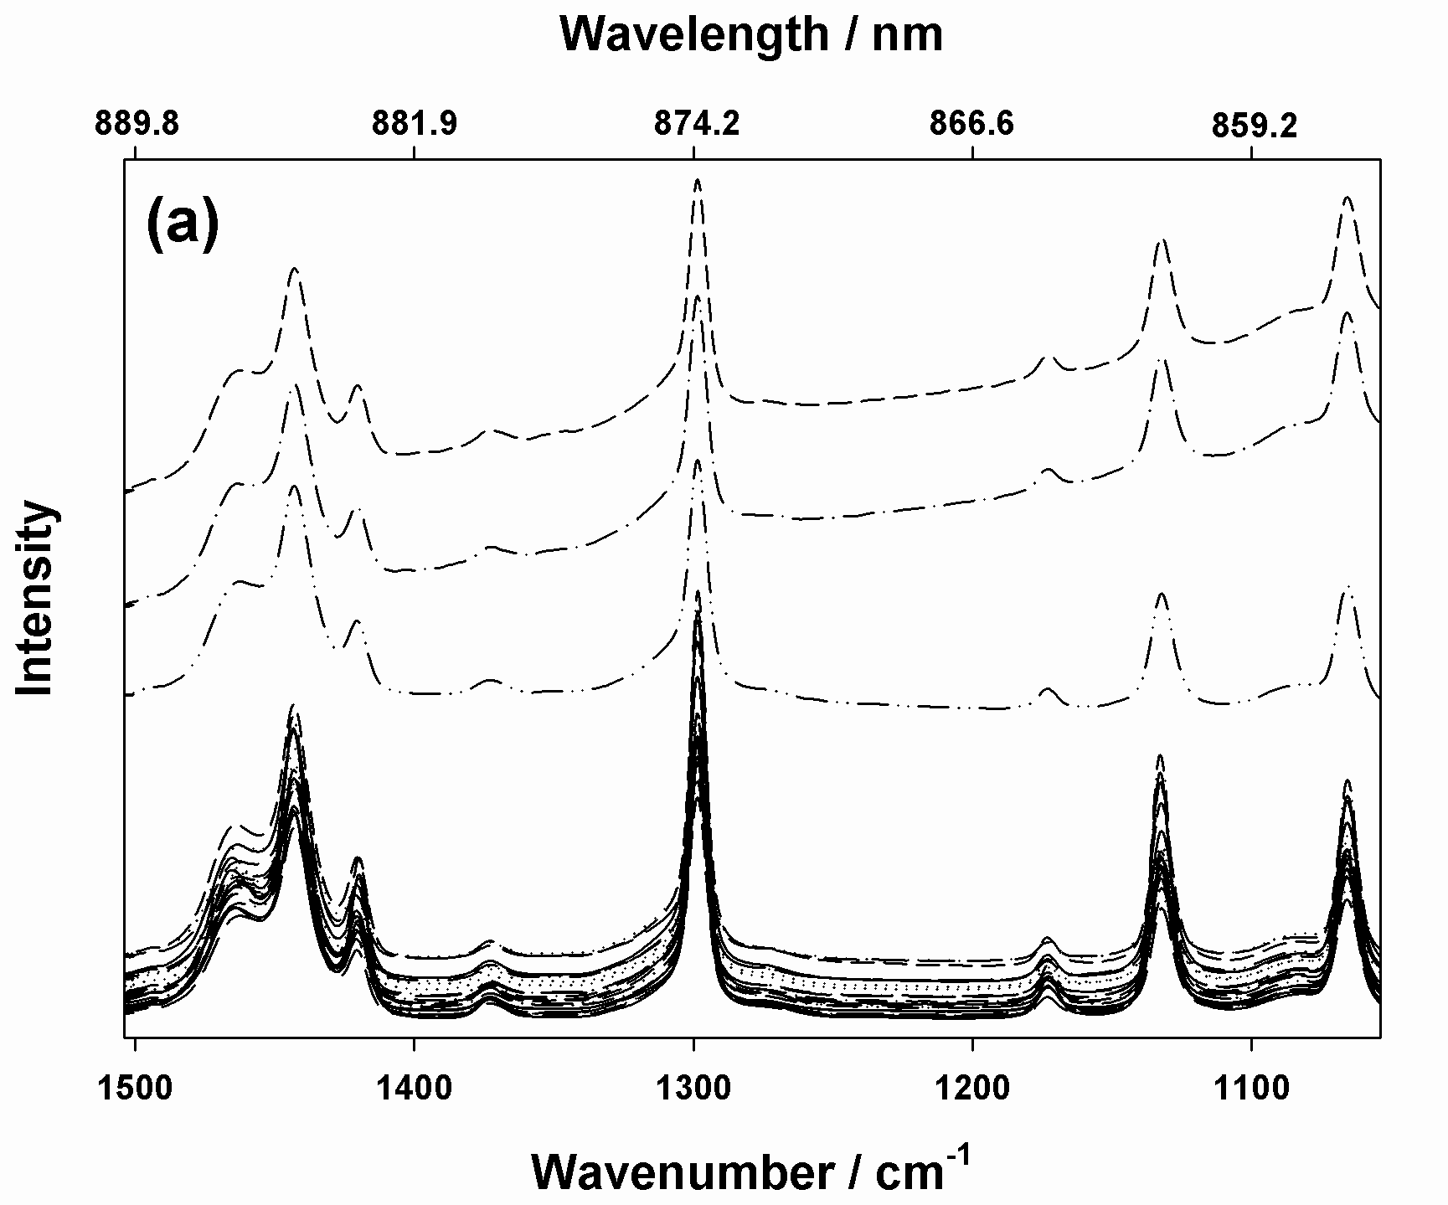 | 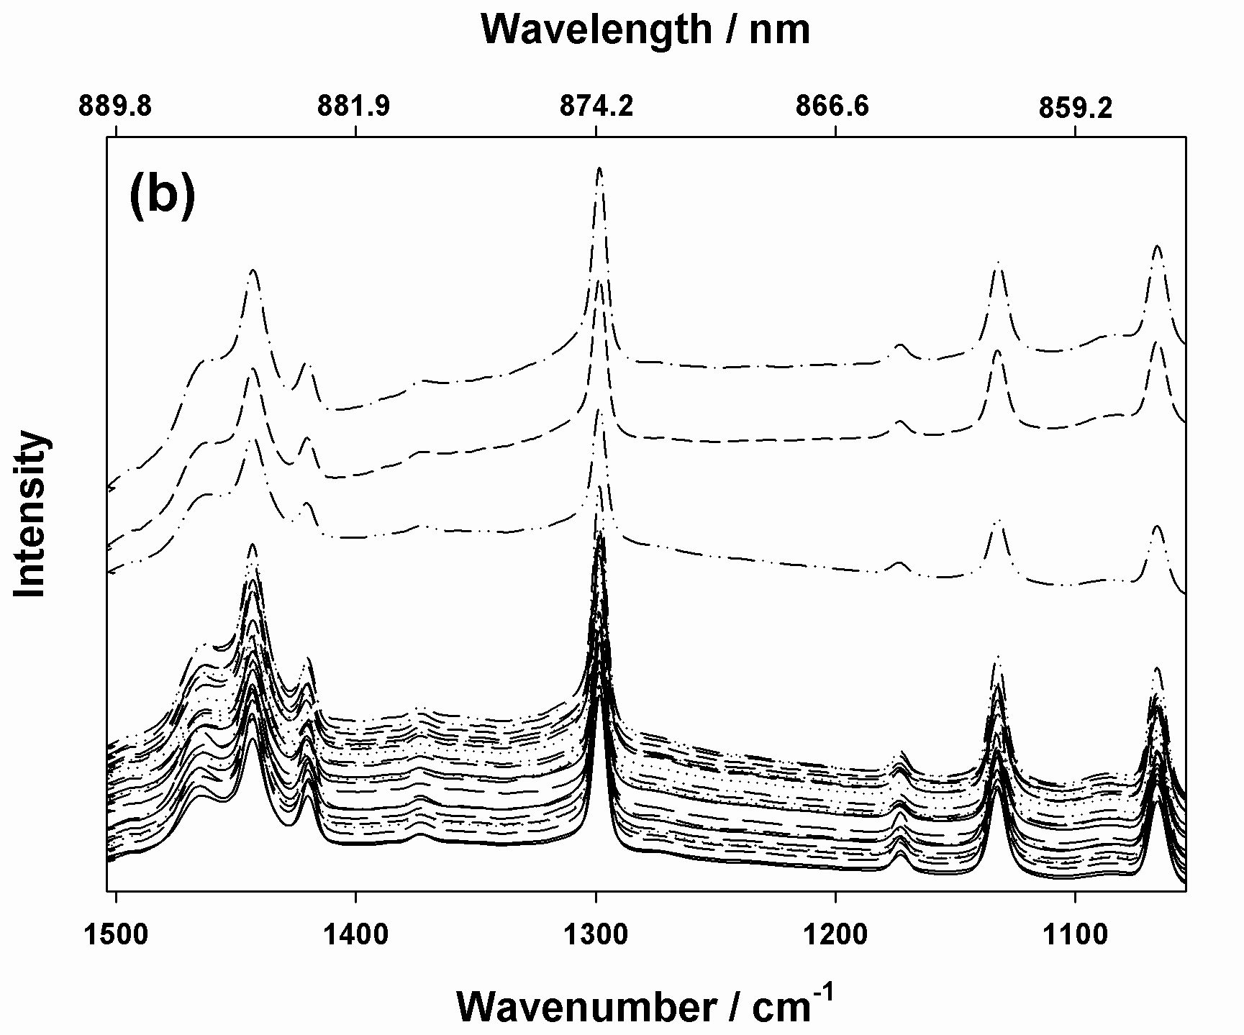
Figure 1. Raman spectra of Back-scattering (a) and Transmission (b) mode
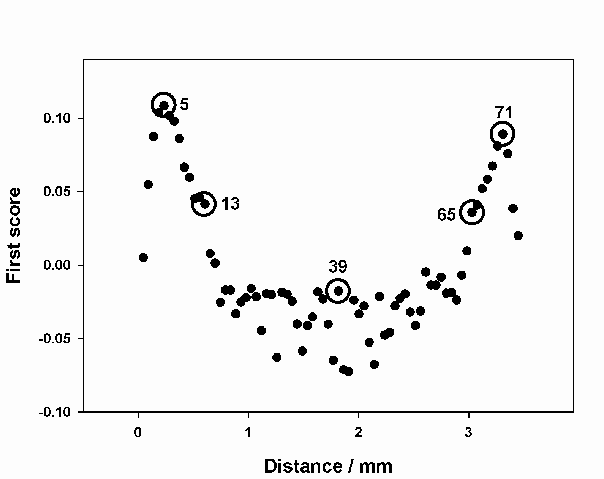 | 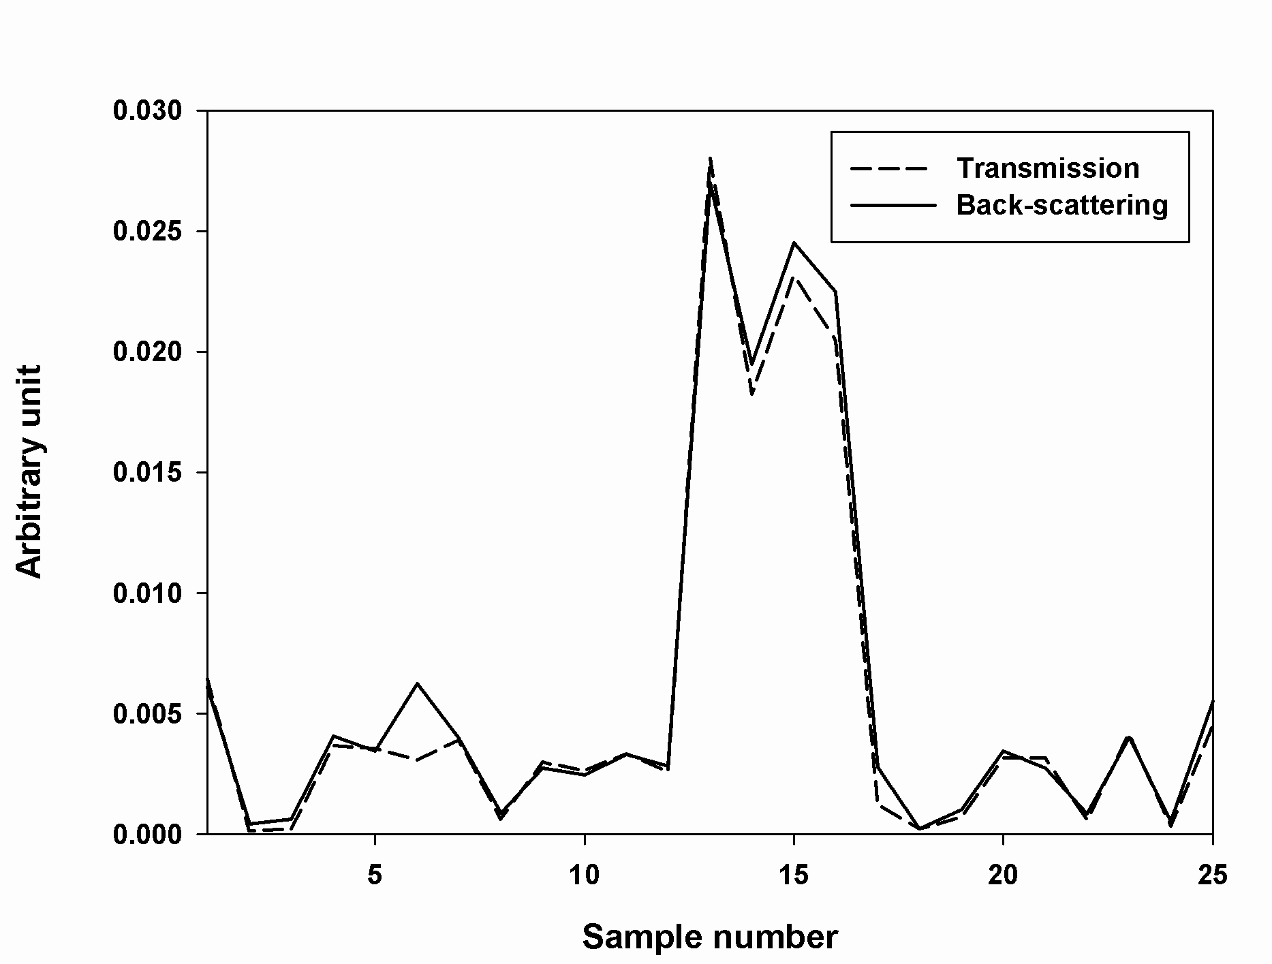
Figure 2. Variation of first score across the map line for high density PE pellet | Figure 3. Auto-power spectra of back-scattering and transmission mode

[Results and Discussion]
Figure 1 (a) and (b) shows back-scattered and transmission Raman spectra (1504-1054 cm⁻¹) collected from all 25 PE pellet. Just based on simple visual comparison, overall spectral features are almost similar to each other. Except for three spectra superimposed with fluorescence background, the baseline of back-scattered spectra are nearly flat across the 1504-1054 cm⁻¹ range; while, those of transmission spectra are slightly titled. When back-scattering mode is used, the resulting baselines has gentle slopes from high to low wavenumber; while, spectra collected by transmission mode have baselines with less slope due to the more scattering-caused attenuation of Raman signal relatively in the lower wavenumber range. Partial least squares (PLS)⁵ regression was used to determine the density of PEs by using the Raman spectra collected by transmission and its accuracy was compared with that using back-scattered Raman spectra. Initially, 20 and 5 samples were assigned to the calibration and validation sets, respectively. All possible combinations were tested and the whole spectral range (1504-1054 cm⁻¹) was used for PLS. The resulting MSEP was 0.00067 g·cm⁻³ with the use of 7 factors; while, the MSEP obtained using back-scattered Raman spectra was 0.00083 g·cm⁻³ with the use of also 4 factors.

[Conclusion]
The combination of selective Raman features and reproducible spectral collections with correct sample representations using the transmission mode led to a highly accurate determination of the density of polyethylene pellets. Although the spectra of both modes were no discernible difference, the accuracy for the determination of PE pellets was comparable to that of back-scattering mode. Even if it has been studied about the polymer pellet from long time ago, the results presented in this study promote transmission Raman mode over back-scattering Raman mode for the quantitative analysis of diverse polymer pellets.

[Reference]
[1] M. J. Kim, H.Chung, Analytica Chimica Acta 632 (2009) 122–127
[2] H. Sato, M. Shimoyama, T. Kamiya, T. Amari, S. Sasic, T. Ninomiya, H. W. Siesler, Y. Ozaki, Journal of Applied Polymer Science 86 (2002) 443–448

국문초록양식예
(한글도 영문과 동일하게 작성함, 단 font는 신명조체)

